**Conda commands**

FIRST CONDA ENV MUST BE CRATED (Conda create env.docx)!

Needed Terminal in PyCharm:

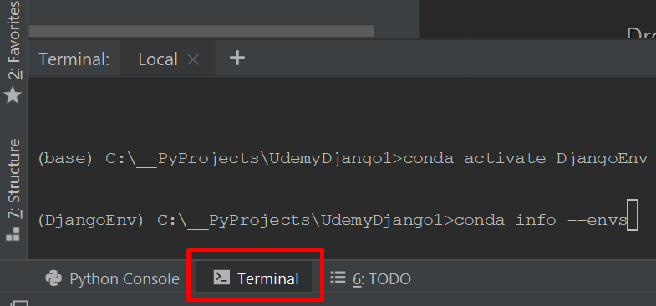

**COMMANDS:**

1. conda info –envs → show all created conda envs
2. conda install django
3. conda create --name DjangoEnv python=3.7 → new conda env with python version
4. conda activate [env name] // conda deactivate [env name]